**LEBANESE AMERICAN UNIVERSITY**

**USAID – HIGHER EDUCATION SCHOLARSHIP PROGRAM**

**HES - Volunteering Program Verification Form**

This form is to be used to document volunteering hours. If a student volunteers for multiple organizations, a separate form must be used for each organization. **This form must be turned in by the 28th of each month, the latest.**

I certify that the scholar Amal al rajab completed a total of 13 hours of service at Life Sculptor.

The hours were completed hours as per the below:

Hours # 0 (date) _30/09 – 5/10_ (initials of supervisor) __A.K.___

Hours # 0 (date) _7/10 – 11/10_ (initials of supervisor) __A.K.___

Hours # 7 date) _14/10 – 18/10 (initials of supervisor) __A.K.___

Hours # 6 date) _21/10 -25/10 (initials of supervisor) __A.K.___

Brief description of the activities the scholar performed or participated in:

I took for this month on research task which is about The Role of Nutrition in Preventing Chronic Diseases , After completing the research task, i had prepared a PowerPoint presentation summarizing my findings. Then I had developed 8 workshop ideas focused on preventing chronic diseases through nutrition. Moreover Amal is the PPT Team Supervisor in the Will & Wellness Club where she assign tasks to the volunteers , review the tasks submitted by the volunteers and then send it to the Head of Teams at Life Sculptor .

Written feedback about the scholar’s performance:

Amal conducted thorough research on nutrition and chronic disease prevention, creating a concise PowerPoint presentation and developing workshop ideas. As the PPT Team Supervisor, she demonstrates effective leadership in managing volunteers and ensuring quality submissions.

Please rate the overall performance of the scholar at your organization:

|  |  |  |  |
| --- | --- | --- | --- |
|  | Mastery (5) | Proficient (3) | Emerging (1) |
| **Problem solver** | X |  |  |
| **Engaged & Committed** | X |  |  |
| **Open-minded & multicultural** | X |  |  |

Signature

& stamp

__________________________

_

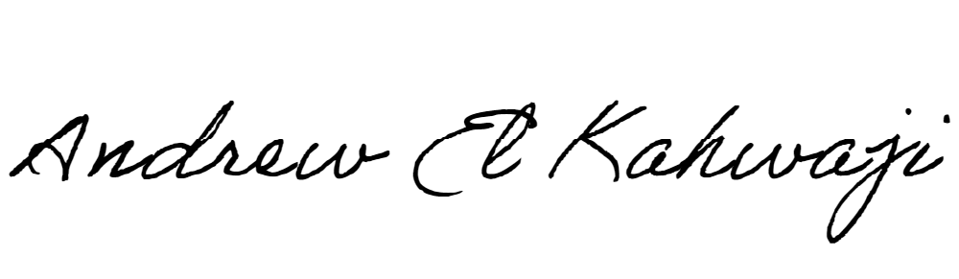

Printed Name _Andrew El Kahwaji_

Date __26/10/2024___

Email __andrew.lifesculptor.coo@gmail.com __

Phone __+961 71 914 378__

**LEBANESE AMERICAN UNIVERSITY**

**USAID – HIGHER EDUCATION SCHOLARSHIP PROGRAM**

